**Mackrell International Annual General Meeting 2024**

Wednesday 8th May to

Sunday 12th May 2024



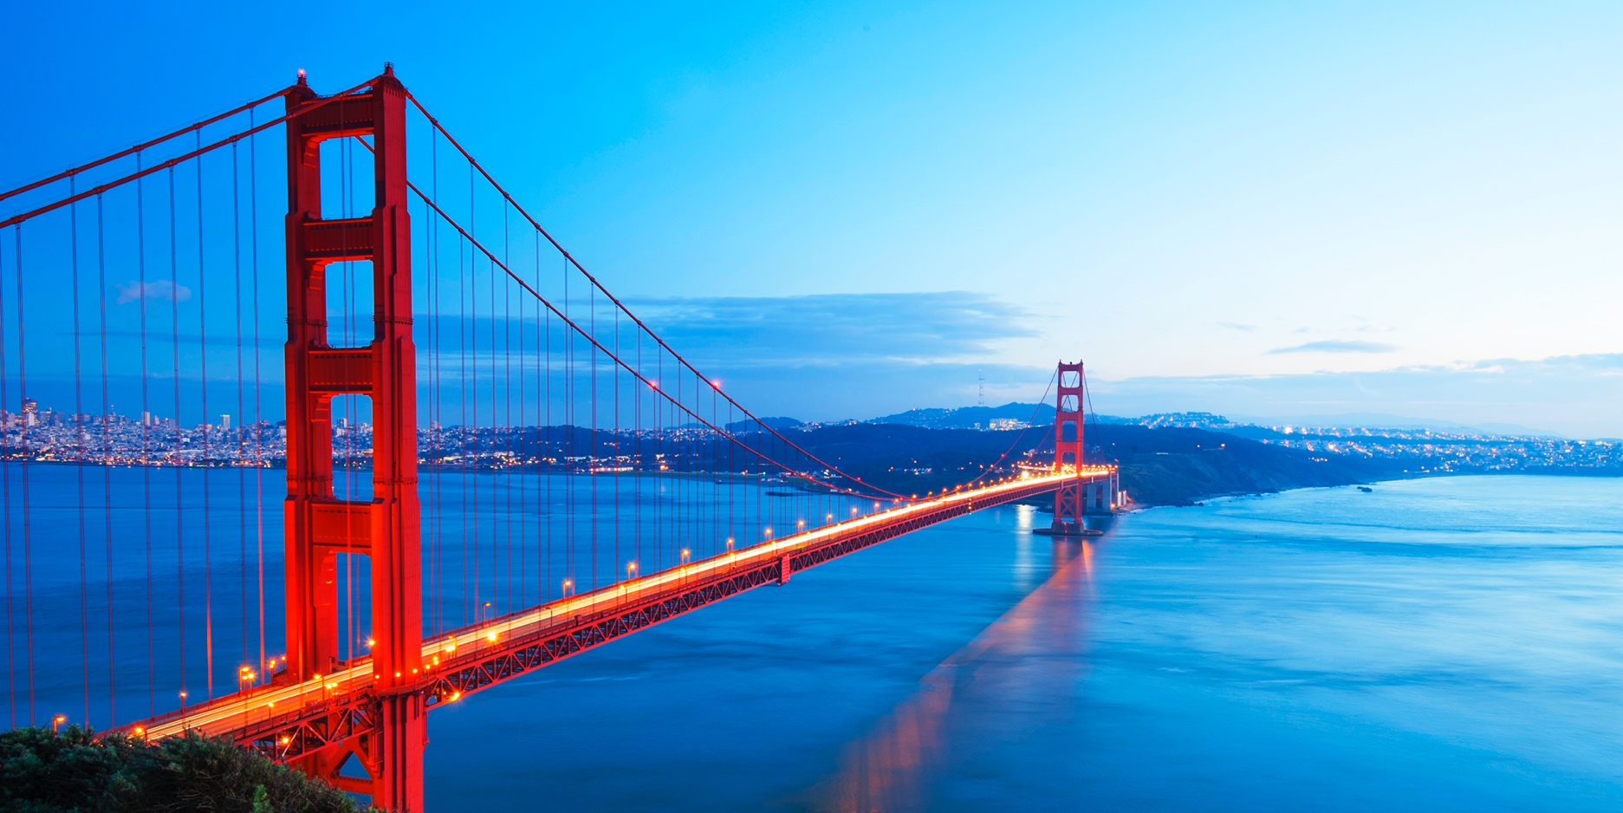

Location: **San Francisco, USA** Hosted by: **Hoge Fenton**



**Meeting Venue and Hotel Accommodation:**

**Fairmont San Francisco**

950 Mason Street, San Francisco, California 94108

+1 (415)772-5000

www.fairmont.com/san-francisco

­­

**Why this meeting should be top of your list to attend in 2024:**

San Francisco is home to one of the most diverse populations in the country and well known for its innovation. At MI AGM 2024 you will hear directly from venture capitalists, technology CEOs, and women executives, and will learn how diversity and innovation are connected.

At the springboard of Silicon Valley success stories such as Apple, Google, Meta, Tesla, and many others, join your Mackrell International colleagues to network, connect and identify joint opportunities and discuss the issues of the day then return to your law firms with their insights on how to address challenges such as recruiting, retention, productivity, and marketing.

**During the Business Meeting you will hear from:**

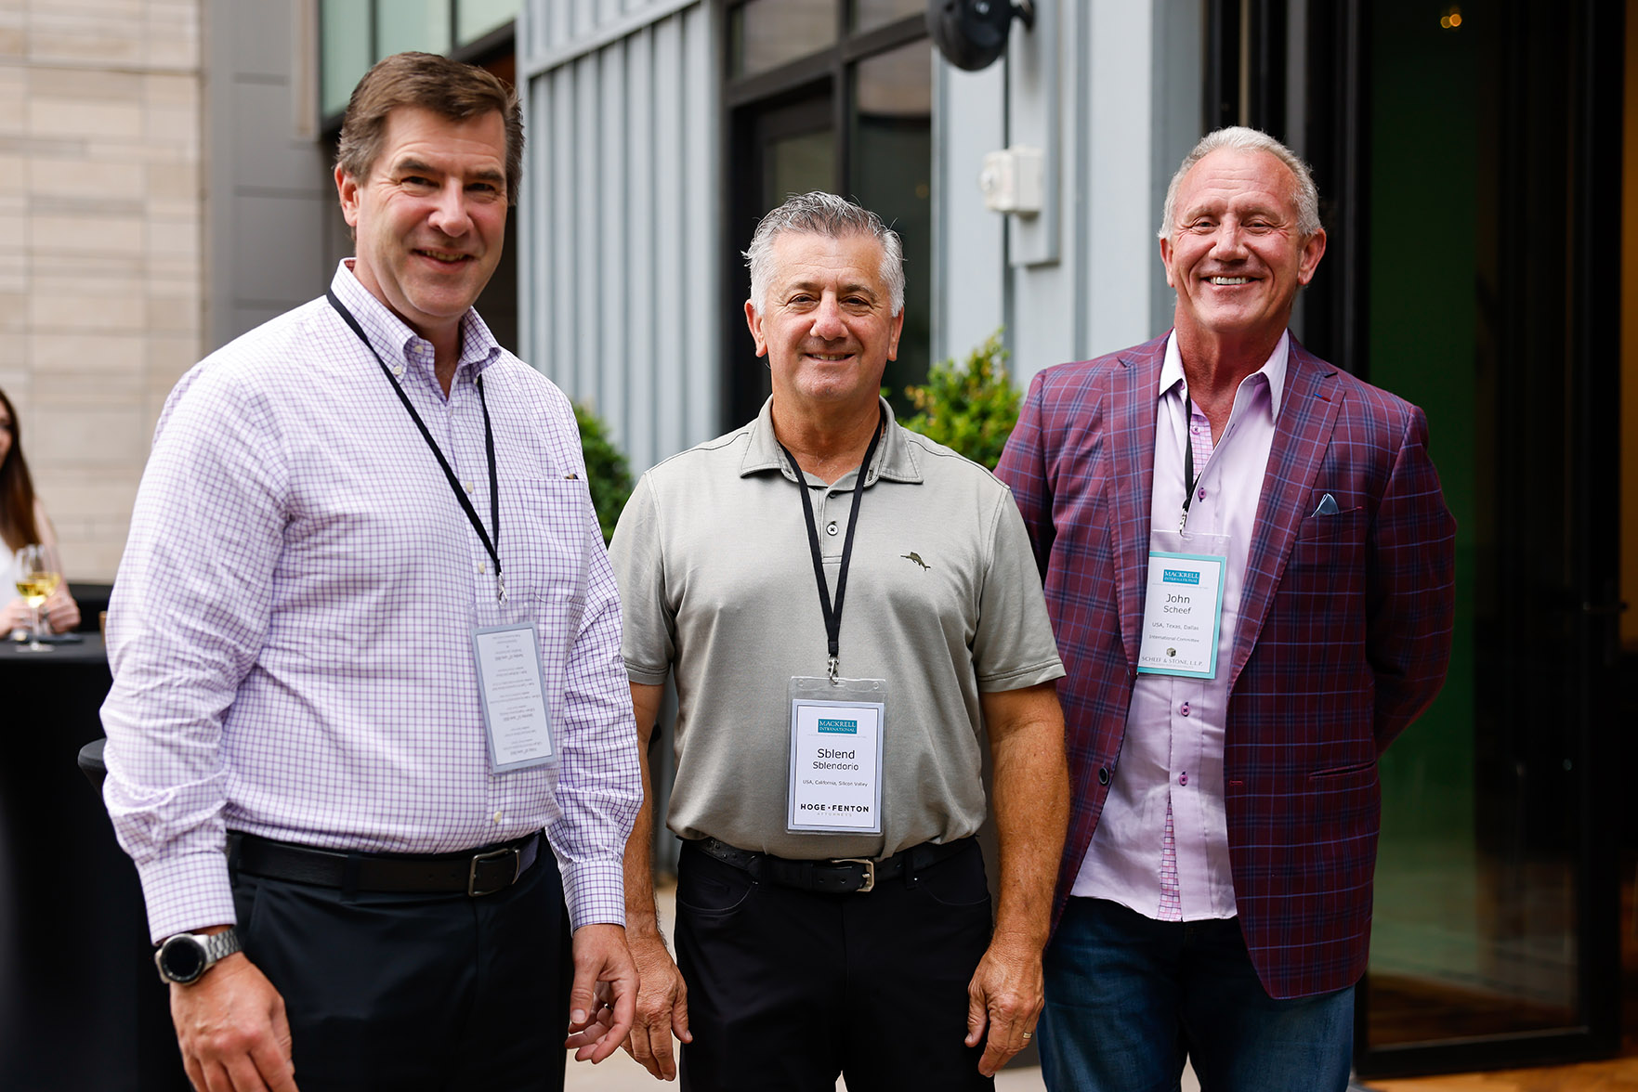

**Your host, Sblend Sblendorio**

[**Natasha Parrett**](https://www.hogefenton.com/our-people/natasha-m-parrett/) of Hoge Fenton: Moderator of the Women in Leadership panel on Friday morning

[**Bala Ramamurthy**](https://www.balaramamurthy.com/bio) Director of Flight Safety, SpaceX. Keynote Speaker on Friday

[**Paul Witkay**,](https://www.allianceofceos.com/about_leadership/detail/paul-witkay) founder of the Alliance of CEOs, moderator of the CEO panel on Thursday afternoon

[**Jacqueline Fader**](https://sensiba.com/company/leadership/jacqueline-fader/), partner at Sensiba, moderator of the Venture Capital panel on Thursday Morning

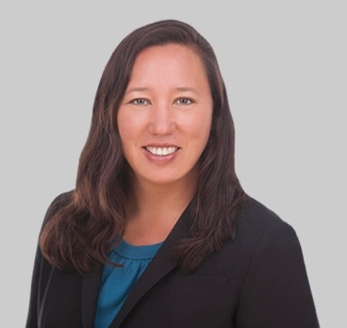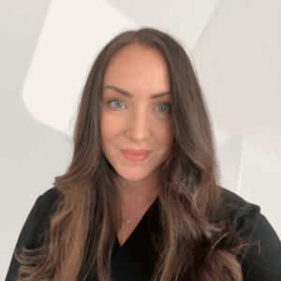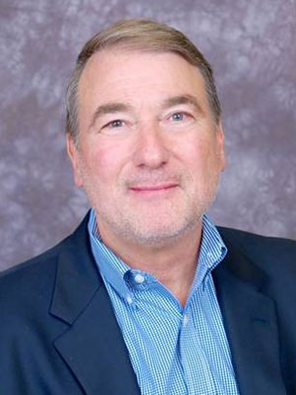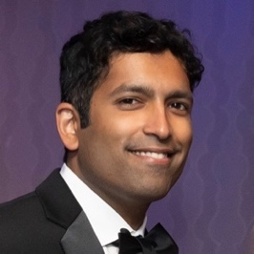

**Programme -** Tuesday to Friday

**Tuesday 7th May 2024**

**09.30 – 16.30 IC Meeting (IC Only)**

**Wednesday 8th May 2024**

**09.30 – 12.30 MI APAC Meeting**

**14.00 – 17.00: Arrival and Meeting Registration**

**18.30 onwards: Welcome Reception and Dinner**

**Thursday 9th May 2024**

**Full Day: Business Meeting**

**AP Programme, Thursday**

**Silicon Valley Tour:** Journey into the heart of Silicon Valley to see the Information Age come to life at the **Computer History Museum**, located just a few blocks from Google headquarters followed by lunch at **Stanford University Faculty Club.**

Evening Dinner at [**R & G Lounge**](https://www.rnglounge.com/), the ‘go-to’ destination for gourmet Cantonese cuisine.

**Friday 10th May 2024**

**Full Day: Business Meeting**

**Women’s Group Lunch**

**AP Programme, Friday**

**San Francisco Bay tour:** See **Angel Island**, the **Ferry Building**, the island prison of **Alcatraz** with views of the **Golden Gate Bridge** with lunch and a walking tour of the historic **Barbary Coast.**

Evening dinner is at **Fort Mason** with fantastic views of the sunset over the **San Francisco Bay** and **Golden Gate Bridge.** Hoge Fenton introduces a first ever ‘choose your own menu’ dinner with food trucks to meet everyone’s taste and Friday Night becomes Casino Night with roulette, blackjack and more to find out who is to be crowned the Casino King or Queen.

Fairmont San Francisco

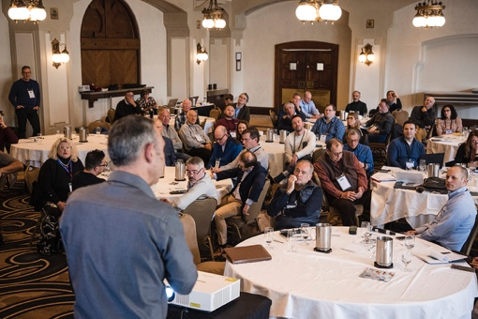

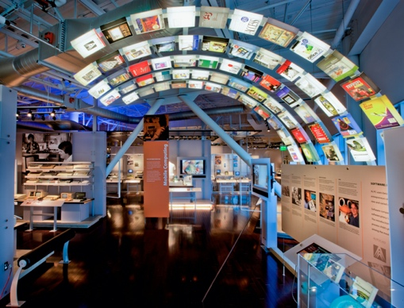

The Computer History Museum

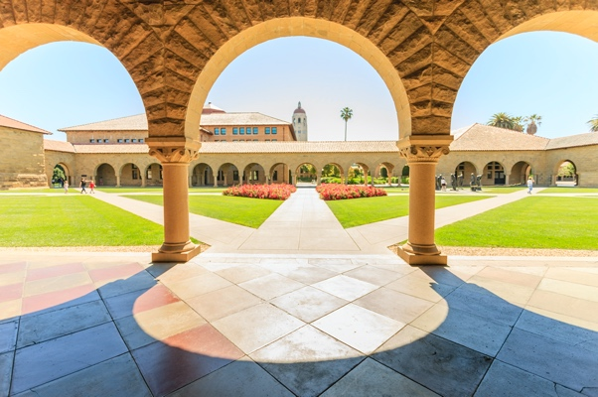

Stanford University

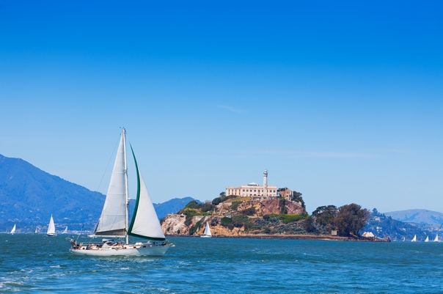

Alcatraz

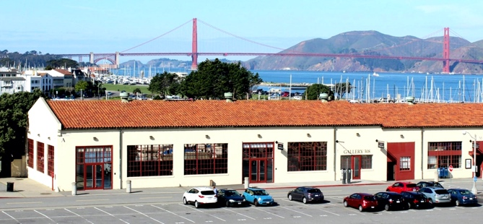

Fort Mason

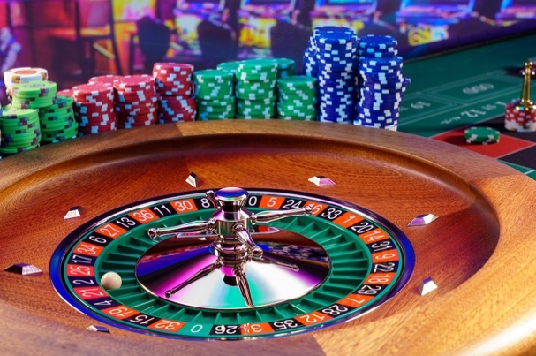

**Programme –** Saturday and Sunday

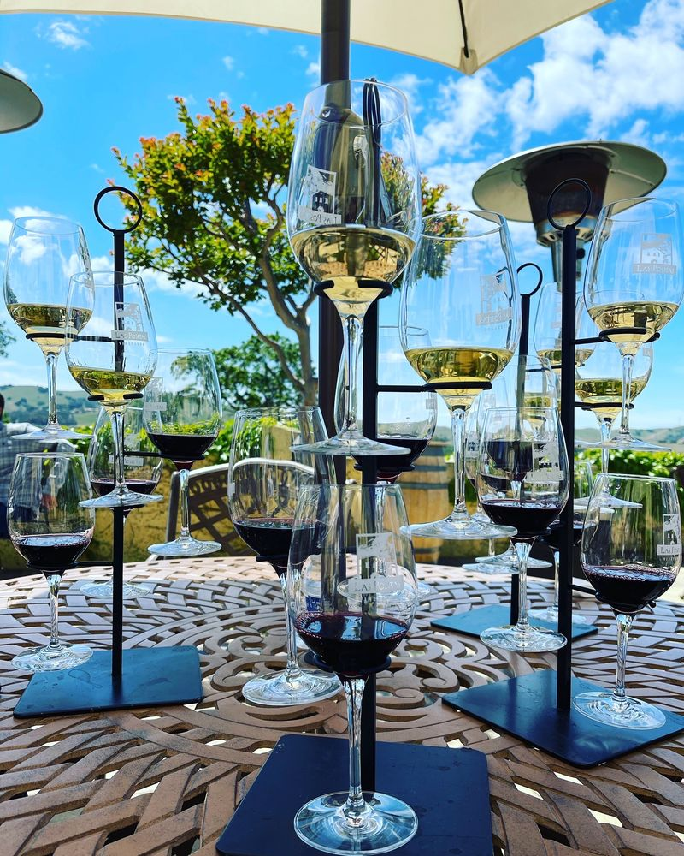

Las Positas Vineyards

**Saturday 11th May 2024**

**A full day excursion for Delegates and Accompanying Persons**

The day begins with an authentic Wine Country experience at [**Las Positas Vineyards**](https://www.laspositasvineyards.com/team-4): unwind, sip and savour; enjoy world-class wines paired with a gourmet lunch, co-hosted by the winemaker, Brent Amos, and the chef, Curt Pipes.

This is followed by a science discovery tour with two alternate visits to ground-breaking laboratories at the forefront of technology.

The [**Lawrence Livermore National Laboratory Visitors Center**](https://www.llnl.gov/community-education/discovery-center), home of the Nuclear Fusion project where you’ll hear about the history of this National Laboratory and about the National Ignition Facilit - a football stadium sized building where more fusion energy was created than the energy put in—a first in human history - only last December.

[**Daybreak Labs**](https://daybreaklabs.io/), a biotech incubator, where we will hear from their executive director about life science incubation and the developments taking place in this area.

The meeting closes with a special Wine Country evening of live music, delicious food and drink at [**The Almost Famous Wine Lounge**](https://www.almostfamouswine.com/) and, of course, all in the company of your Mackrell International colleagues.

**Note: this is a full day excursion, there is no return to the hotel until around 10 pm**

**Sunday 12th May 2024**

**Free time to sightsee before departure**

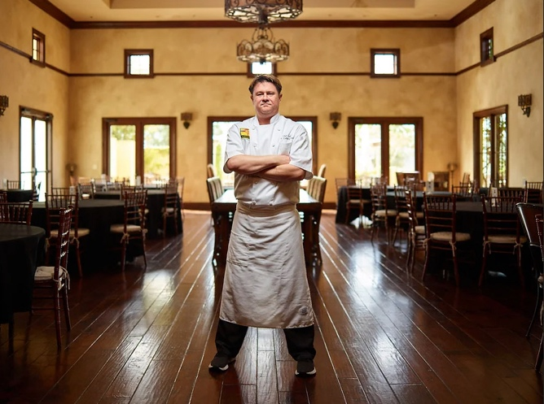

Kurt Pipes

Curt Pipes

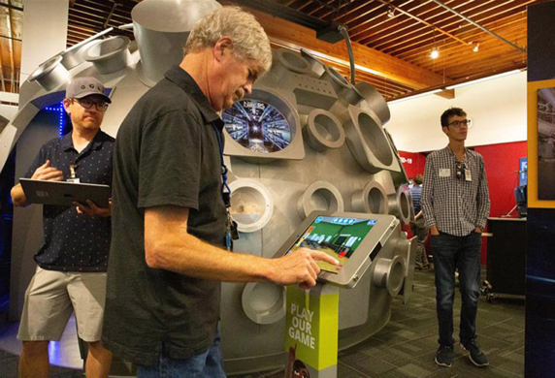

Lawrence Livermore Vistor Center

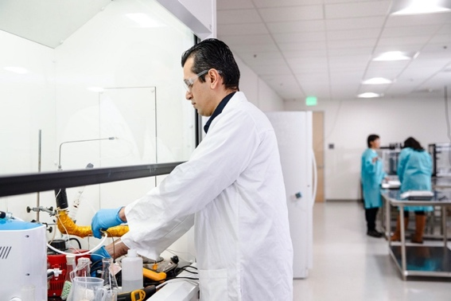

Daybreak Labs

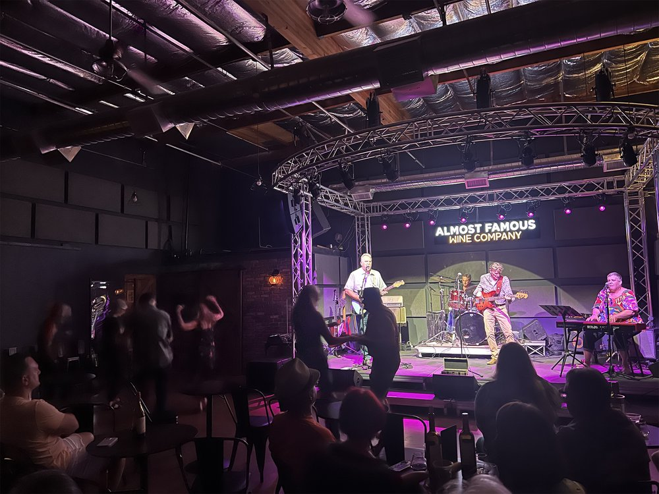

The Almost Famous Wine Lounge