PRE-ARRIVAL INFORMATION

Visa information
Delegates from some countries will require a visa to enter Canada. Please check that you meet all visa requirements for entry into Canada. https://www.cic.gc.ca/english/visit/visas.asp
There have been delays in issuing visas due to Covid therefore should you need a Letter of Invitation for visa purposes please email Mackrell HQ as soon as possible mackrell.hq@mackrell.net

The Hotel
Fairmont Banff Springs
Address: 405 Spray Avenue, Banff, Alberta, Canada t1L 1J4
Phone: +1 (403) 762-2211
Web: https://www.banff-springs-hotel.com/

Transport from Calgary Airport (YYC) to the hotel
It is approximately 140 km from Calgary airport to Banff with a travel time of approximately 1.5 hours.

BANFF TOWN
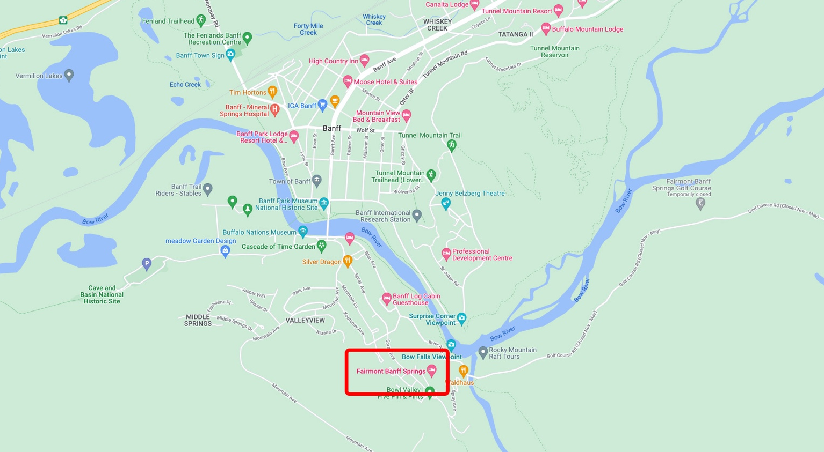

Shuttle (recommended option):
Banffairporter runs regular shuttle buses to and from the hotel. Tickets should be booked in advance and they are situated directly outside the airport
https://banffairporter.com/rates/
Cost: CAD78 one-way, CAD156 return

Taxis:
Taxis are available. Approximate cost CAD250 one-way

Currency and Exchange
The currency in Canada is CANADIAN DOLLAR (CAD or CDN)
There are two ATMs on the Lobby Level of the hotel.
All major credit cards are accepted in most hotels, shops and restaurants.

Climate
The average temperature in Banff in April is a daytime high of 9.7°C and a night time low of -2.2°C. On average it rains on 11 days in April with 160 hours of sunshine. See comments on dress code. https://weather-and-climate.com/banff-April-averages

Remember the temperature will be colder high up in the mountains.

Covid Requirements
On October 1, 2022, all COVID-19 border requirements, including vaccination, mandatory use of ArriveCAN, and any testing and quarantine or isolation requirements, ended for all travellers entering Canada by land, air or sea. https://travel.gc.ca/travel-covid?utm_campaign=gac-amc-covidoct1-22-23&utm_source=wizard-start&utm_medium=redirect&utm_content=en

Dress Code
Welcome dinner: Business casual
Business Meeting: Casual
Thursday night dinner: Casual
Friday night Gala Dinner: Smart
Saturday day event: Casual with warm/waterproof outdoor clothing and sturdy walking/hiking boots
Saturday night dinner: Casual

Accompanying Persons Activities: Casual with warm/waterproof outdoor clothing and sturdy walking/hiking boots

Remember the temperature will be colder high up in the mountains.

Time Zone
In April the time zone is Mountain Daylight Time [MDT] which is UTC/GMT -6

Sales Tax
Goods & Services Tax is 5%

Tipping and Service Charge
Tipping is customary in Canada. It is customary to tip approximately 15-20% on the total bill before tax, less for poor service, more for truly exceptional service

Electric Current
In Canada the power sockets are of type A or B
https://www.worldstandards.eu/electricity/plug-voltage-by-country/
https://www.worldstandards.eu/electricity/plugs-and-sockets/ab/

USEFUL LINKS:
https://roadtripalberta.com/
https://www.tripadvisor.co.uk/Attractions-g154911-Activities-Banff_Banff_National_Park_Alberta.html
https://www.thecrazytourist.com/top-25-things-to-do-in-calgary/
https://banff.ca/89/Visiting

ESSENTIAL CONTACTS:
911 : Emergency Police, Fire and Ambulance
811 : Non emergency Health Advice

