PRE-ARRIVAL INFORMATION

Visa information
Delegates from some countries will require a visa to enter the United Kingdom. Please check that you meet all visa requirements for entry into the UK https://www.gov.uk/check-uk-visa
Should you need a Letter of Invitation for visa purposes please email Mackrell HQ mackrell.hq@mackrell.net

The Hotel
Sea Containers
Address: 20 Upper Ground, South Bank, London SE1 9PD
Phone: +44 (0) 20 3747 1000
Web: www.seacontainerslondon.com

Transport from Heathrow Airport (LHR) to the hotel by train/tube
The fastest link between Heathrow and central London is Heathrow Express https://www.heathrowexpress.com/#/ . Non-stop trains run to Paddington Station every 15 minutes, and journey time is 15 minutes from Terminals 2 and 3 (a few minutes more from Terminals 4 or 5).

You can then get the London Underground from Paddington to Waterloo Station (10 min walk to the hotel) or Blackfriars Station (7 min walk to the hotel)

Transport from Gatwick Airport (LGW) to the hotel by train/tube
The Gatwick Express is the fastest way into Central London. Trains run every 15 minutes between Gatwick Airport's South Terminal and Victoria Station every day from 5am to 00.30am. The journey time is 30 minutes and the service is non-stop to Victoria station.

You can then get the London Underground from Paddington to Waterloo Station (10 min walk to the hotel) or Blackfriars Station (7 min walk to the hotel)

Transport from City Airport (LCY) to the hotel by train/tube
The Docklands Light Railway (DLR) is an overground system connecting East London to the London Underground network. The London City Airport DLR station makes transport from the airport fast and convenient with trains departing every 8 to 15 minutes.

Take the DLR to Canning Town Station and transfer to the London Underground to Waterloo Station (10 min walk to the hotel) or Blackfriars Station (7 min walk to the hotel).

Taxis:
Licensed taxis can be recognized as black cab taxis or with a specific authorised taxi license plaque on the car. Travellers are advised to avoid unlicensed taxis.

All black cab taxis accept credit cards.

Approximate cost of a taxi to Central London is:
London Heathrow: £90.00 - £100.00 (duration 1 hour)
London Gatwick: £100.00 - £120.00 (duration 1 hour)
London City: £40 - £60 (duration 40 minutes)

Uber:
Has services in London and from the airports and can be organised through the Uber App.

Location of Sea Containers Hotel in relation to Waterloo and Blackfriars Tube Stations
Waterloo Station (10 min walk to the hotel) or Blackfriars Station (7 min walk to the hotel).
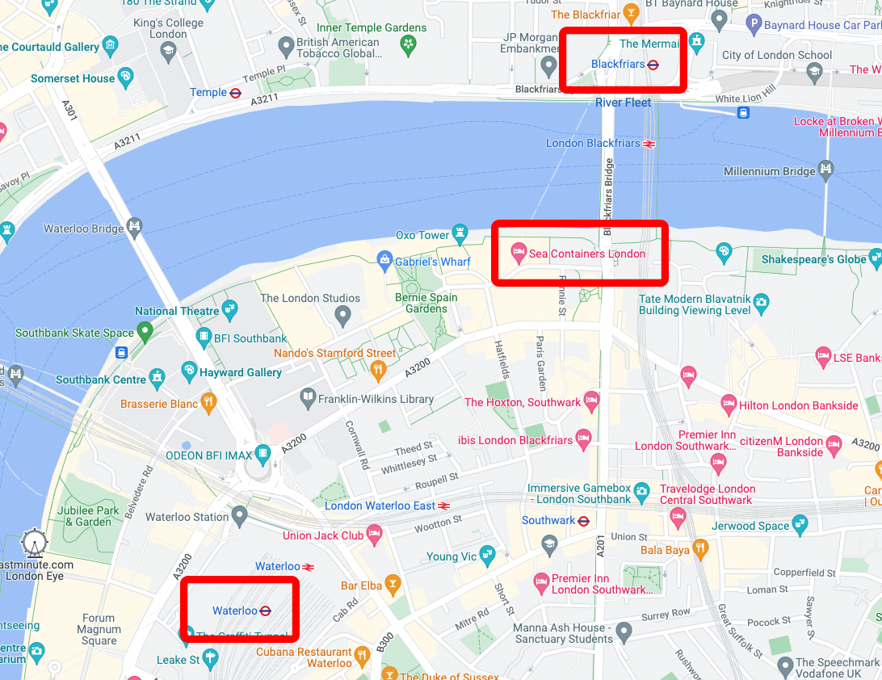

Currency and Exchange
The currency in United Kingdom is BRITISH POUND (GBP).
There is an ATM on the Studio Floor of the hotel and they are widely available in London and currency exchanges can be conducted at local banks.
All major credit cards are accepted in most hotels, shops, taxis and restaurants.

Climate
The average temperature in London in September is a daytime high of 18 degrees and a night time low of 11 degrees C. On average it rains on 10 days in September so check in advance if you’ll need wet weather clothing https://www.metoffice.gov.uk/weather/forecast/gcpvj0v07

Covid Requirements
You do not need to take any COVID-19 tests, nor complete a UK passenger locator form before you travel, nor quarantine when you arrive in England. This applies whether you are vaccinated or not.
https://www.gov.uk/guidance/travel-to-england-from-another-country-during-coronavirus-covid-19

Dress Code
Welcome dinner: Business casual
Business Meeting: Casual
Thursday night dinner: Formal – Suit and tie, cocktail dress
Friday night Dinner: Casual
Saturday day event: Casual
Saturday night Gala dinner: Business casual.

Accompanying Persons Activities: Casual and comfortable shoes

Time Zone
In September the time zone is British Summer Time [BST] - UTC/GMT +1

Sales Tax
Sales tax is included in all prices quoted in shops and restaurants.

Tipping and Service Charge
Tipping is customary in United Kingdom. Some venues will automatically add service so check the bill. If not, the amount to tip is a personal choice but is approximately 10 % of the bill.

Electric Current
In United Kingdom the power sockets are of type G
https://www.worldstandards.eu/electricity/plugs-and-sockets/

USEFUL LINKS:
https://www.visitlondon.com/
https://www.timeout.com/london/things-to-do/101-things-to-do-in-london

ESSENTIAL CONTACTS:
999 : Emergency Police, Fire and Ambulance
111 : Non emergency Health Advice

